**Name: Saad Rehman  
Student ID: 21F-9640  
Section: 3A**  
**Degree: BS-CS  
Teacher Name: Sir Abdul Qadeer Bilal  
Course: EL-2003 (COAL)  
Lab Number: 10  
……………………………………………………………………………**

**Note: Program all Questions on AFD and Put code + Screenshot in the Word File till end of Lab.**

**Qno.1**

Write a code which will take position and length of snake and then print it.

Position Input: you will take x and y position (explain in reading material)

**Answer**

[org 0x0100]

jmp start

message: db 15 ; string to be printed

length: dw 15 ; length of the string

clrscr:

push es

push ax

push di

mov ax, 0xb800

mov es, ax ; point es to video base

mov di, 0 ; point di to top left column

nextloc:

mov word [es:di], 0x0720 ; clear next char on screen

add di, 2 ; move to next screen location

cmp di, 4000 ; has the whole screen cleared

jne nextloc ; if no clear next position

pop di

pop ax

pop es

ret

printstr:

push bp

mov bp, sp

push es

push ax

push cx

push si

push di

mov ax, 0xb800

mov es, ax ; point es to video base

mov al, 80 ; load al with columns per row

mul byte [bp+10] ; multiply with y position

add ax, [bp+12] ; add x position

shl ax, 1 ; turn into byte offset

mov di,ax ; point di to required location

mov si, [bp+6] ;point si to string

mov cx, [bp+4] ;load length of string in cx

mov ah, [bp+8] ;load attribute in ah

nextchar:

mov al, [si] ; load next char of string

mov [es:di], ax ; show this char on screen

add di, 2

loop nextchar ; repeat the operation cx times

pop di

pop si

pop cx

pop ax

pop es

pop bp

ret 10

start:

call clrscr ; call the clrscr subroutine

mov ax, 30

push ax ; push x position

mov ax, 20

push ax ; push y position

mov ax, 1 ; blue on black attribute

push ax ; push attribute

mov ax, message

push ax ; push address of message

push word [length] ; push message length

call printstr ; call the printstr subroutine

mov ax, 0x4c00 ; terminate program

int 0x21

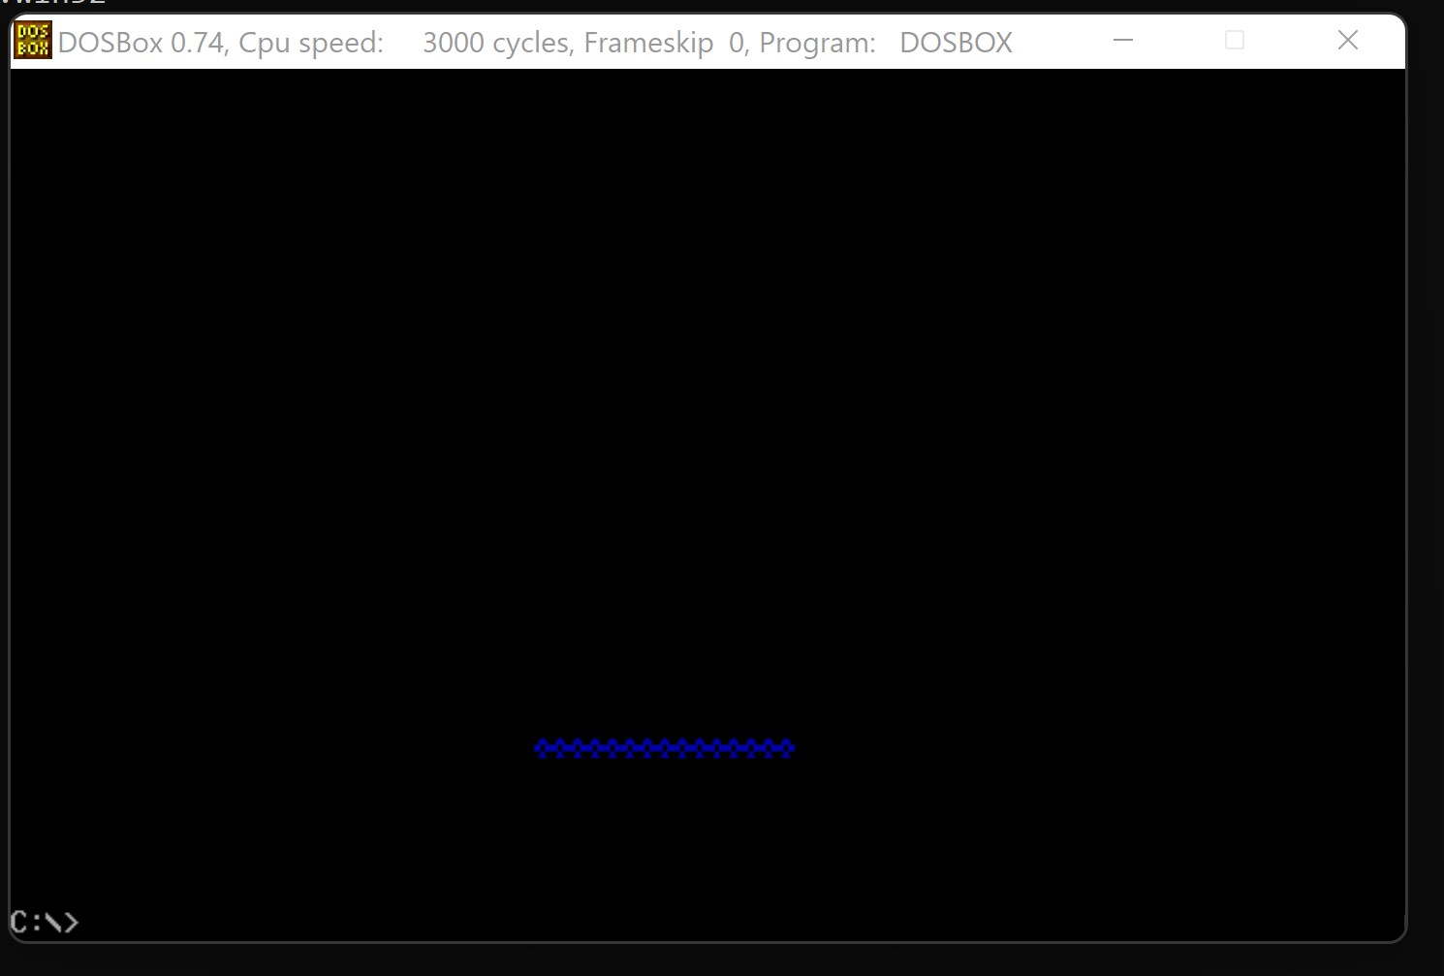

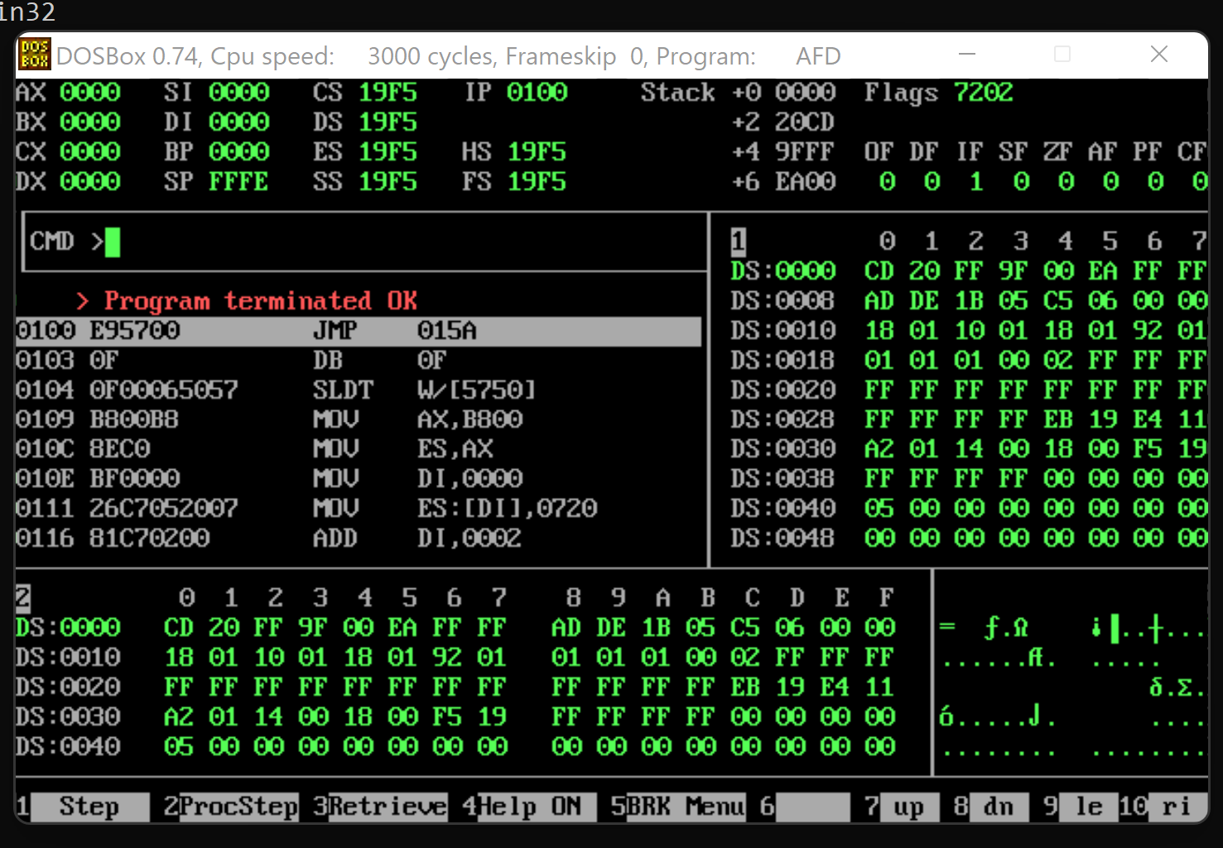

**Qno.2**

Write a code to print this pattern.(code should be generic)

1

1 2

1 2 3

1 2 3 4

1 2 3 4 5

**Answer**

[org 0x0100]

jmp start

num: dw 5

clrscr:

push es

push ax

push di

mov ax, 0xb800

mov es, ax

mov di, 0

next:

mov word [es:di], 0x0720

add di, 2

cmp di, 4000

jne next

pop di

pop ax

pop es

ret

print:

push bp

mov bp, sp

push es

push ax

push di

push cx

push bx

mov ax, 0xb800

mov es, ax

mov di, [bp+6]

mov cx, [bp+4]

mov bx, 0x0731

nextloop:

mov word [es:di], bx

add di, 2

add bx, 1

loop nextloop

pop bx

pop cx

pop di

pop ax

pop es

pop bp

ret 4

triangle:

push bp

mov bp, sp

push ax

push cx

mov cx, 0

mov ax, [bp+4]

dec ax

shl ax, 1

loopp:

add cx, 1

push ax

push cx

call print

add ax, 158

cmp cx, [bp+4]

jne loopp

pop cx

pop ax

pop bp

ret 2

start:

call clrscr

push word[num]

call triangle

mov ax, 0x4c00

int 0x21

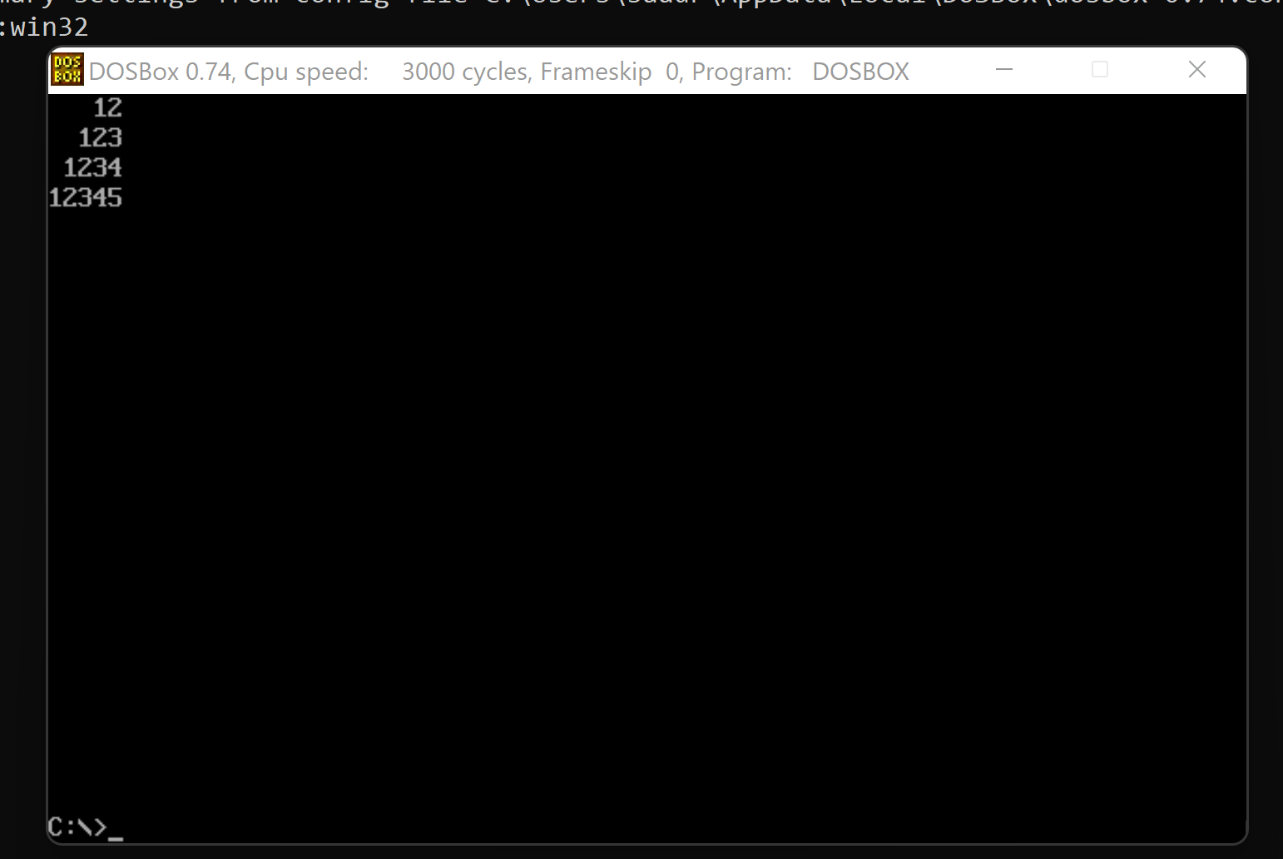

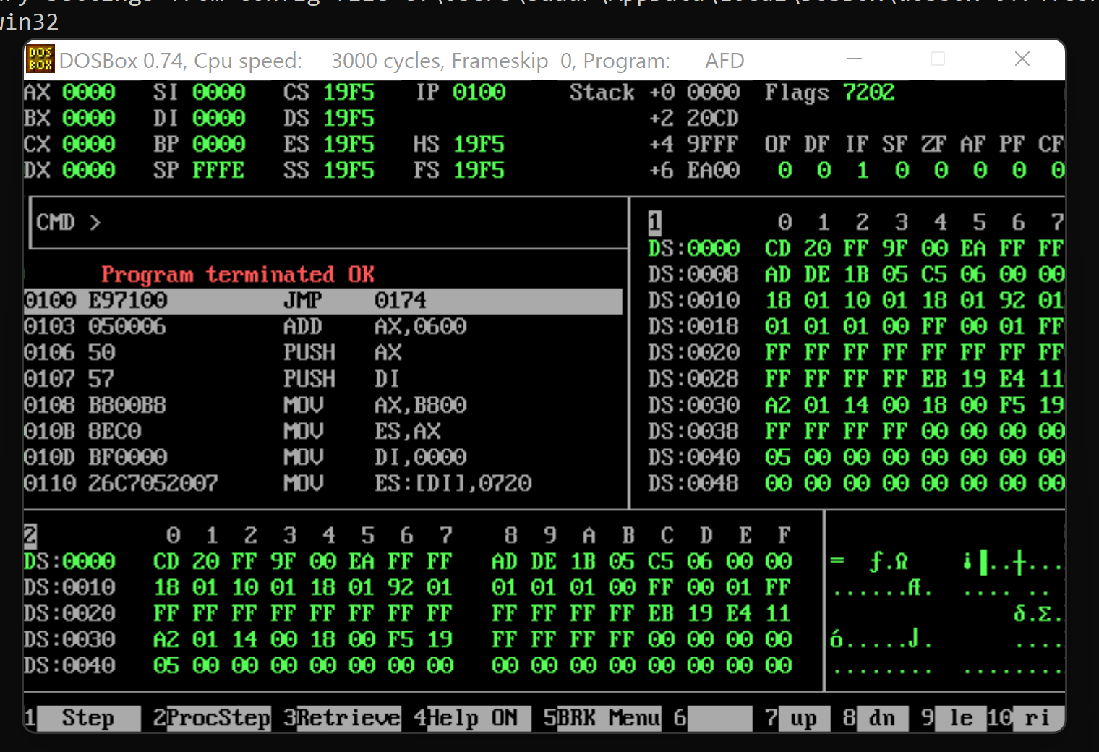

**Note: Use stack for passing parameters and local variables if any variables are required(No**

**Global variables)**

**The END**